Financial Derivatives

Student’s Name
Institution Affiliation
Course Name
Professor’s Name
Assignment Due Date

Financial derivatives

1. Put option
Option price = $47-$43 *e ^( risk free rate * T)
=$ 4* 2.718 ^( 2.78 * 0.05479)
=$ 3.3563
Black Scholes modelC=St​N(d1​)−Ke−rtN(d2​)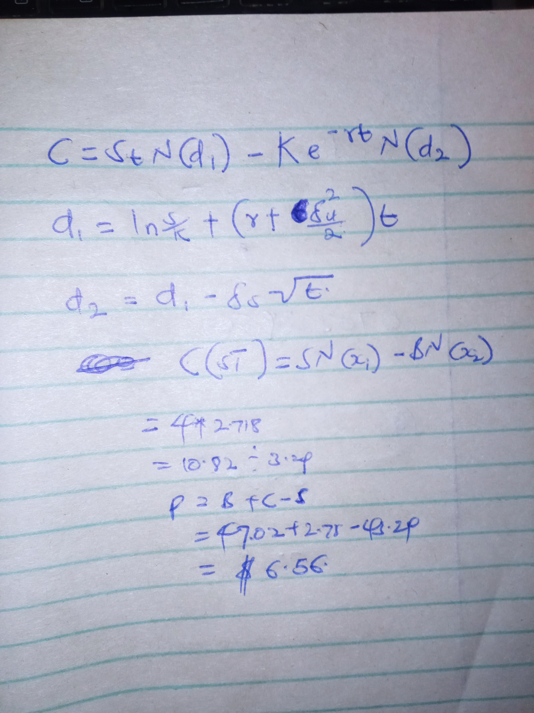

2 Differences
There occurred differences in the two answers since in the first, Binomial, a simple statistic equation, extends the decision point to a multiple points in the answer. The black Scholes was used to calculate the results of extended expiration date. From the view, Binomial was correct to the actual value.
3. Since, the put option will be priced at $2 I will sell short the amount that has been accrued to be got from underlying stock in the period of time. This is because it is increasing its validity slowly and selling it on time will lead to getting of the accurate amount of money. Even a short is much preferable in this kind of a situation.

